1.Write a Mapreduce program to modify Sales of different TV Task 2 ( refer session 5 assignment 2 ) to use a custom partitioner with 4 reducers. Make sure that all records whose company name starts with A-F (upper or lower case) should go to 1st reducer, those starting with G-L to 2nd reducer, those starting with M-R to 3rd reducer and others to 4th reducer

DRIVER CLASS

USE SET PARTITIONER CLASS AND CUSTOMIZE PARTTITIONER

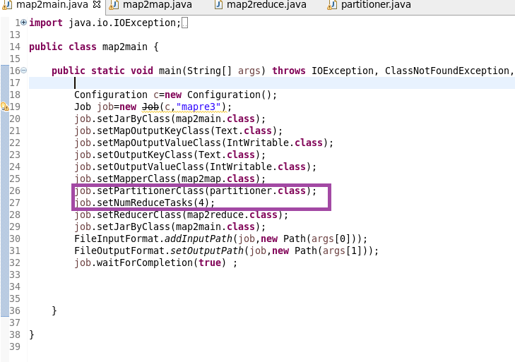

MAPPER CLASS

used mapper splitting each line read by using “|” and storing the output as shown

I will remove NA containing records and then send the company name as key and for each key I will sent 1 as value.So that a count could be made in reducer

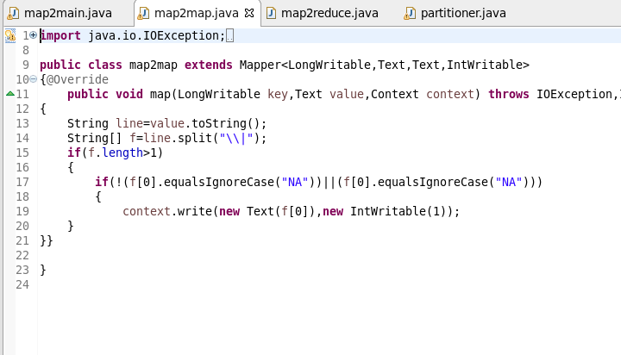

REDUCER CLASS

REDUCER:COUNT the no of units for each company by iterating

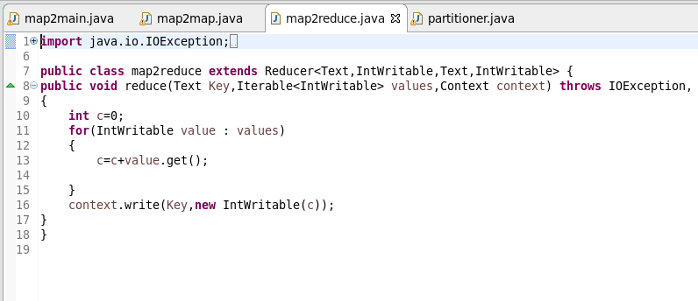

PARTITIONRER CLASS

USED MATCHES FUNCTION AND COMPARE KEY NAME AND SEND IT TO CORRESPONDING REDUCER

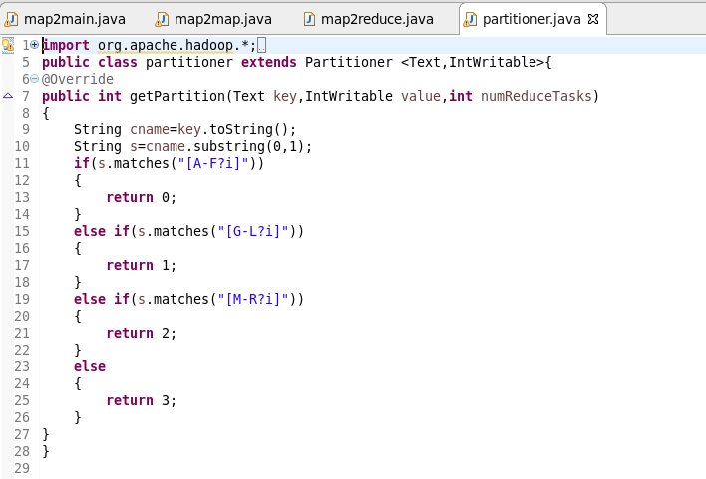

RUNNING JAR

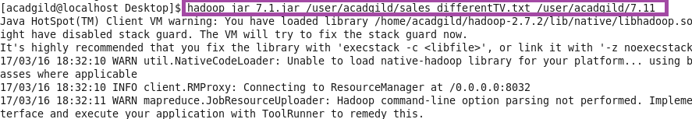

OTPT

A-F OPT IN REDUCER 0

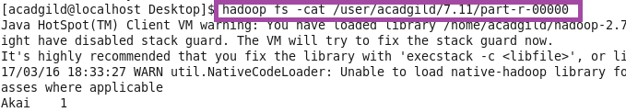

G-L OPT IN REDUCER 1

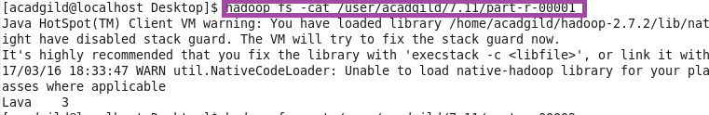

M-R OPT IN REDUCER 2

REST IN REDUCER 3

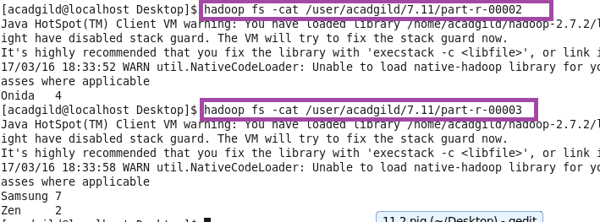

**QN2:Modify Sales of different TV Task 2 (refer session 5, assignment 2) to take advantage of Combiner.**

**Set combiner class and give the reducer class as combiner as the logic for combiner and reducer is the same**

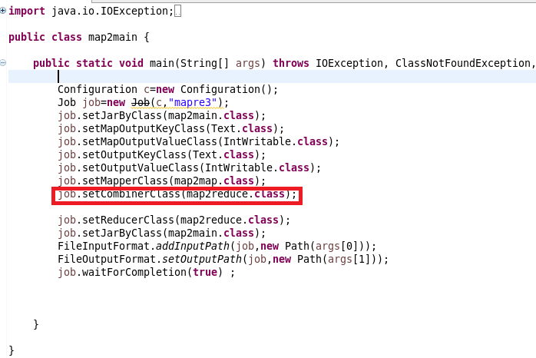

Mapper class

used mapper splitting each line read by using “|” and storing the output as shown

I will remove NA containing records and then send the company name as key and for each key I will sent 1 as value.So that a count could be made in reducer

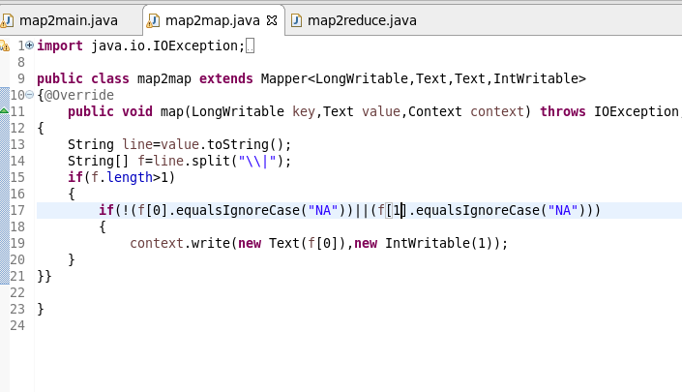

REDUCER

REDUCER:COUNT the no of units for each company by iterating

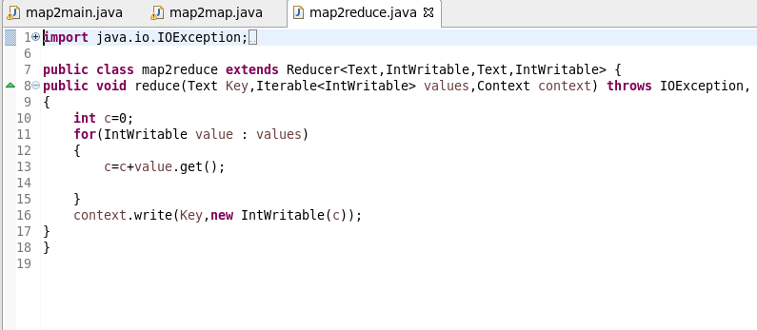

RUNNING JAR

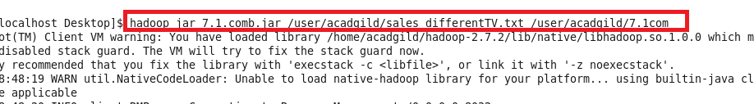

OTPT

